Name: Furthose samreen B
Reg NO: 192511164

Experiment 1: Create a Kanban Board in Jira to Visualize Tasks Aim
To create a Kanban board in Jira with To Do, In Progress, and Done columns, add at least five sample tasks, and move the tasks across the columns to simulate the workflow.
Procedure

- Open Jira online and log in to your account.

- Create a new project using the Kanban template.

- Name the project Software Engineering Kanban.

- Open the project board and verify that the three columns are available: To Do, In Progress, and Done.
- Click the Create button to add five sample tasks:

  - Gather Project Requirements

  - Design Login Page

  - Develop Home Page

  - Test Application

  - Prepare Project Report

- Add the first two tasks to To Do.

- Move Develop Home Page and Test Application to In Progress.

- Move Prepare Project Report to Done.

- Drag and drop tasks between columns to simulate the workflow.

- Verify the task distribution and take a screenshot of the completed board.

Output

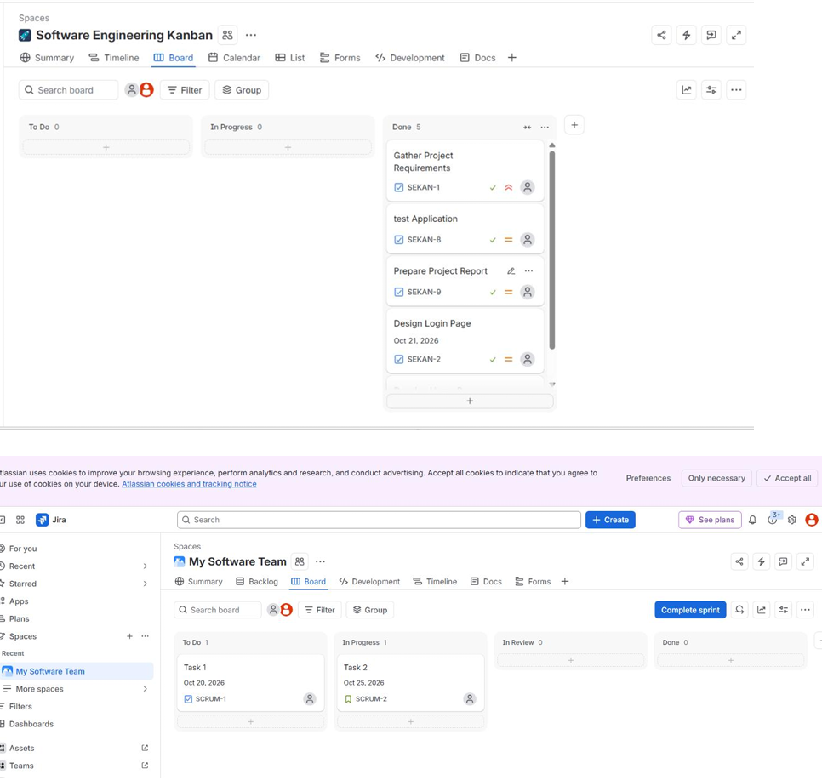

Result

A Kanban board was successfully created in Jira with three columns and five sample tasks. The tasks were organized and moved across the columns to simulate the workflow and visualize project progress.

GITHUB LINK:
https://github.com/192511164simats-source/Software-engineering-

